**React Developer Task Interview**

**Task 1: To Do List**



**Description:** create a simple web application using React.js. The application should allow users to create, mark, and delete tasks in a to-do list.

1. Add a task: Provide input field where users can enter a new task. When the user clicks on the Add Task button, the task should be added to the list.
2. Cross a task: Add a checkbox for every task. When the user clicks on the task box should be ticked, text crossed and the Done counter should increase.
3. Delete a task: When the user clicks on a "Delete" button associated with a task, the task should be removed from the list, and the Done counter should decrease.

**Requirements:**

* Use React to build the application.
* Use appropriate React hooks for managing component state ex: useState.
* Write clean and well-structured code with proper comments where necessary.
* The application should be fully functional.

**Task 2: Figma Design to React**

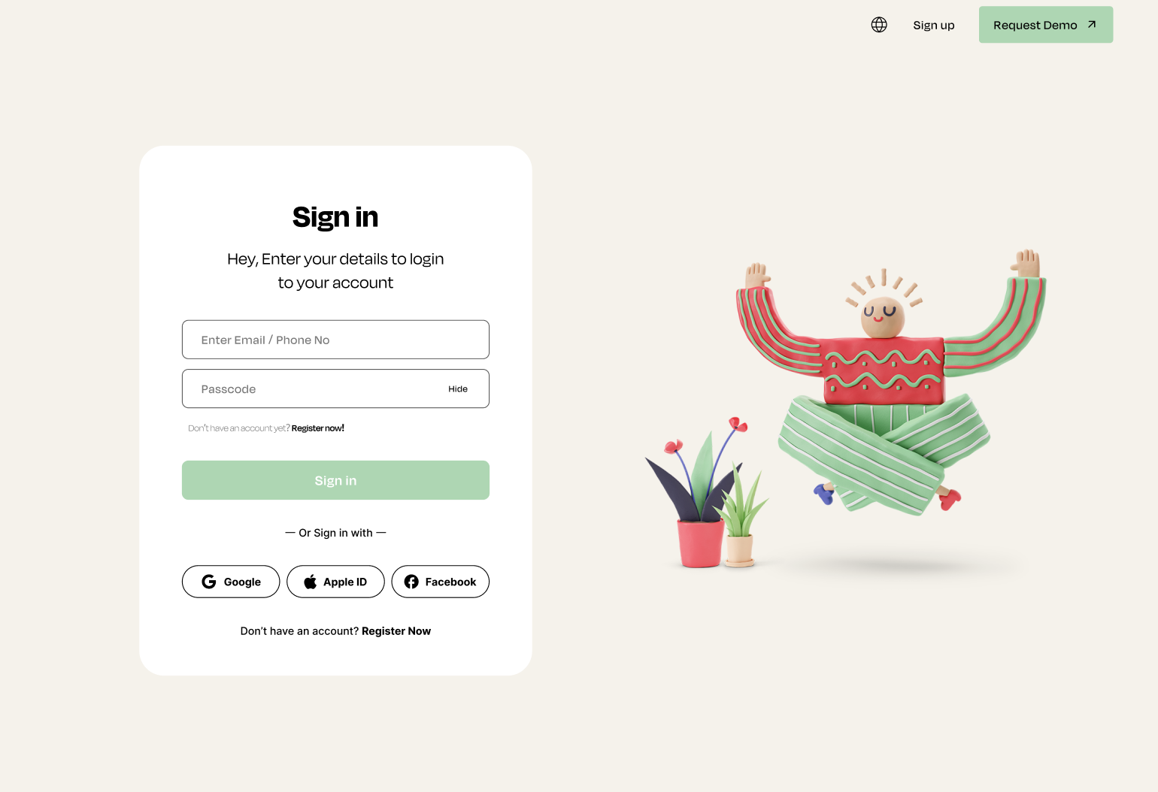

**Description:** for task #2create the page UI using React.js with the Figma design as a reference.

Note: you can download any needed asset and view colour codes from the link provided below. select design from the left, and then switch to dev mode on the top right  
(</> icon),then select any needed asset or colour.

[**Page Design Link**](https://www.figma.com/file/Wqb5wTW8Glcy765nI7iPcE/Log-in-page-(Community)?node-id=1%3A2&mode=dev)

**Verification Criteria:**

* The code should be well-organised, modular, and follow best practices.
* The code should demonstrate a good understanding of React.js concepts, such as components, state management, and hooks.

**Timeframe:** You have **5 days** to complete the tasks.

**Submission Instructions:**

1. Create a new repository on GitHub or another version control platform.

2. Implement the task based on the requirements and verification criteria.

3. Commit your changes regularly, with clear and concise commit messages.

4. Once you're done, share the repository URL with us for review.

We look forward to reviewing your submission. Good luck!